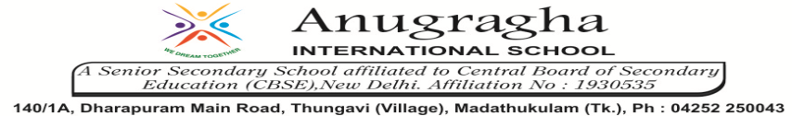

ANNUAL EXAMINATION-FEB-2020

KBQ - 05
NAME | «NAME_OF_THE_STUDENT» |  |  | AD.NO | «ADMNO»
CLASS | VIII-«SECTION» |  |  | EX.NO | «EXNO»
G.D | 19.02.2020 | S.D | 24.02.2020 | SUB | SST
TOPIC: CH:12 INDIA AFTER INDEPENDENCE

Short Answer Type Questions:
1.What did Dr.Ambedkar mean when he said “In politics we will have equality and in social and economic life we will have inequality”?
2.What was the final speech of Dr.B.R.Ambedkar to the constituent Assembly?
3.What was States Reorganization Commission?

Long Answer Type questions:
1.Name three problems that the newly independent nation of India faced.
2.How was the economic development of India visualized in the early decades after independence?
3.Briefly describe the three lists of subjects under the constitution of India.
4.Give an account on the successes and failure of India over 60 years.
5. Briefly describe the India’s foreign policy and Non-Aligned Movement.

HOTS:
1.After Independence , why was there a reluctance to divide the country on linguistic lines?

