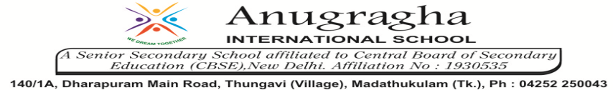

ANNUAL EXAMINATION-FEB-2020

KBQ - 06
NAME |  |  |  | AD.NO
CLASS | VIII- |  |  | EX.NO
G.D | 28/02/2020 | S.D | 02.03.2020 | SUB | SST
TOPIC: CH:10.LAW AND SOCIAL JUSTICE

Short Answer Type Questions:
1.What are tha advantages to foreign companies in setting up production in India?
2.What do you mean when we speak of law enforcement? Who is responsible for enforcement? Why is enforcement so important?
3.How can laws ensure that markets work in a manner that is fair? Give two examples to support your answer.
4.Explain the Right against Exploitation.
5.Why do foreign companies come to India?
6.How can safety laws be enforced by the government?
7.Who is responsible for setting up laws related to environment?
8.What is the major role of the government?

Long Answer Type questions:
1.Write a paragraph on the various roles of the government that you have read about in this unit.
2.What are the sources of environmental pollution in your area? Discuss with respect to (a) air, (b)water and (c)soil. What are the steps being taken to reduce the pollution? Can you suggest some other measures?
3.How was environment treated earlier? What has been the change in perception ? Discuss.
4.How does environment acts as a public facility.
5.How do new laws protect the environment.

HOTS:
1.Do you think victims of the Bhopal gas tragedy got justice . Discuss

