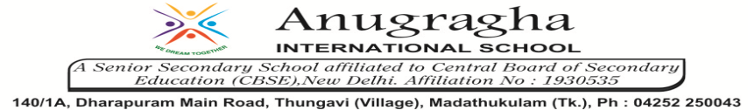

ANNUAL EXAMINATION-FEB-2020

KBQ - 06
NAME | «NAME_OF_THE_STUDENT» |  |  | AD.NO | «ADMNO»
CLASS | VI-«SECTION» |  |  | EX.NO | «EXNO»
G.D | 21.02.2020 | S.D | 24.02.2020 | SUB | SST
TOPIC: CH:9.URBAN LIVELIHOODS

Short Answer Type Questions:

1.In what ways is a permanent and regular job different from a casual job? Discuss
2.Who are self-employed people? Give examples.
3.What is wage employment?
4.What is regular employment?
5.Who are Casual labours?

Long Answer Type questions:

1.Examine the various kinds of urban livelihoods.
2.How does migration link rural-urban livelihoods?

